Comparative report between pneumonia and emphysema

Emphysema is a disease affecting the lungs, specifically when the lungs have been damaged due to smoking cigarettes or other substances and the alveoli become damaged and their delicate surface area for oxygen diffusion is damaged making the alveoli sacs bigger reducing the amount of oxygen that can be diffused. The lack of oxygen diffusion causes shortness of breath when undertaking physical activities like running walking or doing labour.one obvious way to diagnose emphysema is to test breathing and another is to do an x ray on the chest to see if there is obvious damage (diagnosis info from www.betterhealth.vic.gov.au) The current treatments of emphysema are,

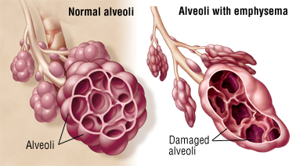

(diagram from Harvard health)

One of the only ways to slow down or treat emphysema (as it cannot be cured) is to stop damaging your lungs whether it be through smoking or etc. As soon as the source of damage is removed you would be stopping its growth but not curing the emphysema. There are some other ways that emphysema can be treated but these treatments are widespread when treating many lung diseases like an asthma puffer etc. The best prevention for emphysema is to never indulge in smoking as that is the main cause of the damage to the alveoli which causes emphysema.

Pneumonia on the other hand, is a disease caused by a viral, bacterial, or fungal infection, these infections causing the alveoli to become inflamed and fill with pus or mucus making breathing and

(diagram from study.com)

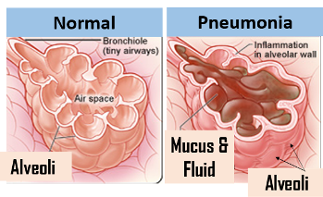Respiration difficult as the pus blocks the way for oxygen to diffuse along with the inflammation also making it harder the extra mucus often coats the inside of the lungs causing a wet chesty cough. Some symptoms of pneumonia are a cough, shortness of breath and a fever (info from ww.lung.org) the most common treatment of pneumonia is antibiotics as antibiotics works on bacteria which is the most common way to catch pneumonia but viral and fungal infections that create pneumonia cannot be treated with antibiotics as it does not work on those types of infections. Blood tests and X rays can help diagnose pneumonia, one through checking lung inflammation and the other by looking at immune system activity (Diagnosis info from www.nhlbi.nih.gov). The ways that you can catch pneumonia involve viral, fungal, and bacterial infections. Some ways to prevent pneumonia are to stay away from sick people and wash your hands(just generally keep good hygiene.

In terms of similarities and differences both diseases they are both similar but different they both effect the alveoli’s ability to diffuse oxygen and the person with the disease’s ability to breath. Although they are both different in the fact that one is caused by human choice (the choice to smoke that damages the alveoli) the other is more random (some factors of catching pneumonia you just cannot avoid) and emphysema is forever but pneumonia is temporary. Both cause coughing and difficulty breathing and can be prevented and treated even if one is incurable. Their respective treatments also differ as one involves abstaining from something and the other is taking medicine like antibiotics. Both diseases can interact with each other though, someone with emphysema can catch pneumonia and their effects would be very dangerous as they both affect the alveoli so the person affected would be getting a double hit of compromised respiration. It is not a good mix and could likely kill the person who is affected if they are part of the elderly population. They both are different but their similarities characterized by the effect they have on the alveoli.